Questions to judge the size

1. What is your height and weight?
2. Do you have a lot of fat on accessary breast on side, underarms, back?
3. You under bust and top bust size?



1. If the back band is too tight, you feel more fit and support?

Questions to keep record on the website

1. What size do you wear?
2. Your waist and hip size
3. What is your breast shape, Well rounded, taking a part, low,
4. Which part of body hurts when you wear bras? Strap, side, center, underwire?
5. If you want to register as member, please create an account →A, If not click here →B

A goes to the section to fill out customer info. When finish, go to front page with her information aside.

B goes to front page and see her information aside.

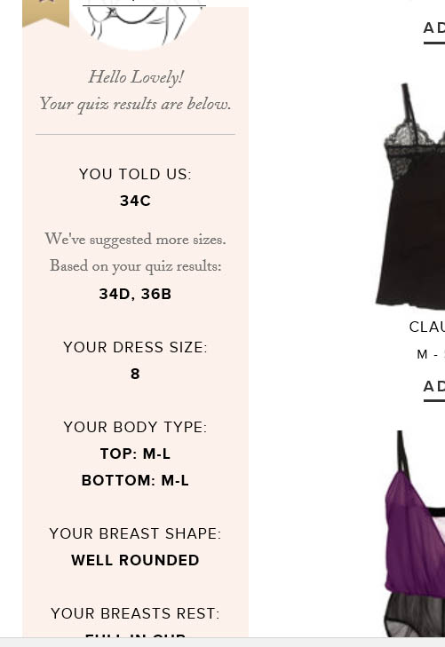

1. Your Current Bra Size
2. Suggested　Size
3. Your Body Size as of 2004/xx/xx
4. Your Body Type
5. Your Breast Shape
6. Your trouble